=========================================================
PRACTICAL – 4:
TOPIC: JOINS AND SET OPERATIONS
=========================================================
Dr.Y Subbarayudu ,Department CSE ,KL University Bachupally Hyderabad
=========================================================
PART 1: CROSS JOIN
=========================================================

STEP 1: CREATE TABLES
---------------------------------------------------------
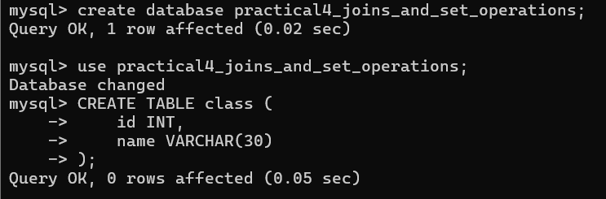
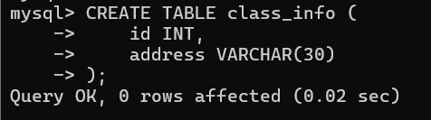

=========================================================
STEP 2: INSERT DATA
=========================================================
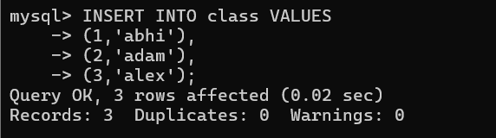
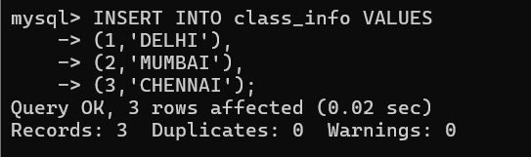

=========================================================
QUESTION 1 - CROSS JOIN
=========================================================
SCENARIO:
School administration wants every student to be paired
with every available city for survey analysis.

QUERY:
SELECT *
FROM class
CROSS JOIN class_info;

OUTPUT:
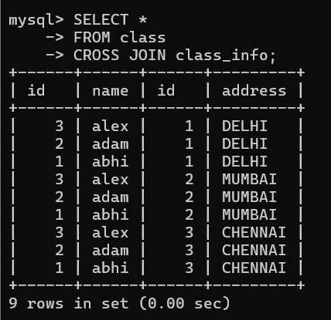

=========================================================
PART 2: INNER JOIN
=========================================================
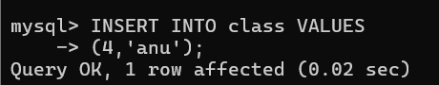

=========================================================
QUESTION 2 - INNER JOIN
=========================================================
SCENARIO:
Management wants only students whose address details
are available in both tables.

QUERY:
SELECT *
FROM class
INNER JOIN class_info
ON class.id = class_info.id;

OUTPUT:
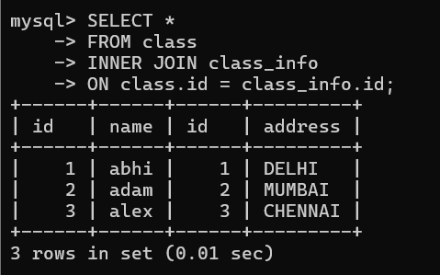

=========================================================
QUESTION 3 - INNER JOIN
=========================================================
SCENARIO:
Find student names and addresses for registered students.

QUERY:
SELECT class.name,
class_info.address
FROM class
INNER JOIN class_info
ON class.id=class_info.id;

OUTPUT:
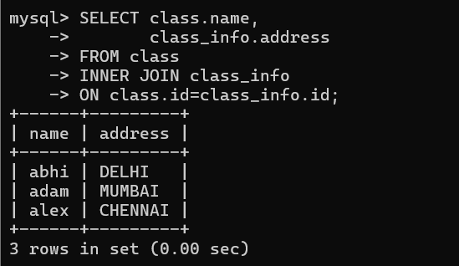

=========================================================
PART 3: NATURAL JOIN
=========================================================

QUESTION 4 - NATURAL JOIN
=========================================================
SCENARIO:
The database administrator wants matching records
automatically joined using common columns.

QUERY:
SELECT *
FROM class
NATURAL JOIN class_info;

OUTPUT:
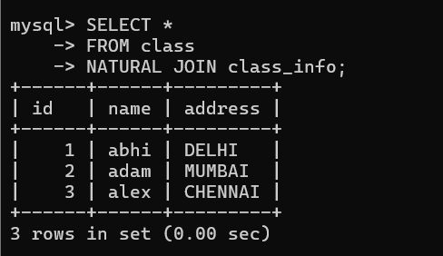

=========================================================
PART 4: LEFT OUTER JOIN
=========================================================
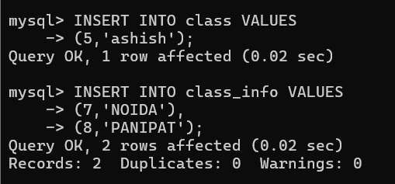

=========================================================
QUESTION 5 - LEFT JOIN
=========================================================
SCENARIO:
School wants all students even if address information
is not available.

QUERY:
SELECT *
FROM class
LEFT OUTER JOIN class_info
ON class.id=class_info.id;

OUTPUT:
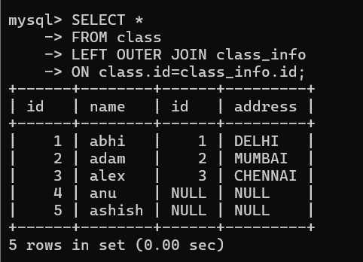

=========================================================
QUESTION 6 - LEFT JOIN
=========================================================
SCENARIO:
Find students who do not have address records.

QUERY:
SELECT *
FROM class
LEFT JOIN class_info
ON class.id=class_info.id
WHERE class_info.id IS NULL;

OUTPUT:
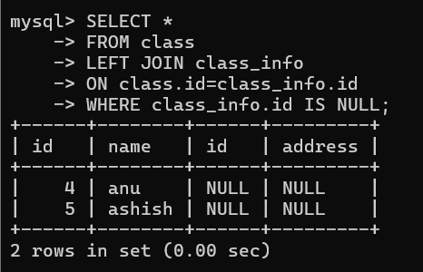

=========================================================
PART 5: RIGHT OUTER JOIN
=========================================================
QUESTION 7 - RIGHT JOIN
=========================================================
SCENARIO:
Administration wants all address records even if
students are missing.

QUERY:
SELECT *
FROM class
RIGHT OUTER JOIN class_info
ON class.id=class_info.id;

OUTPUT:
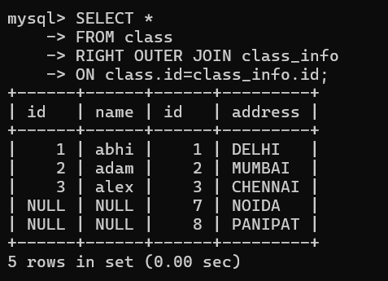

=========================================================
QUESTION 8 - RIGHT JOIN
=========================================================
SCENARIO:
Find address records that do not belong to any student.

QUERY:
SELECT *
FROM class
RIGHT JOIN class_info
ON class.id=class_info.id
WHERE class.id IS NULL;

OUTPUT:
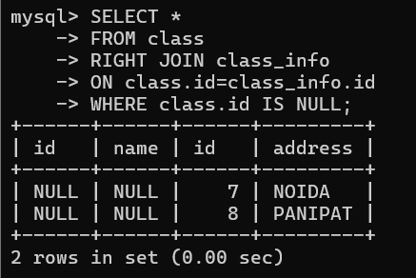

=========================================================
PART 6: FULL OUTER JOIN
=========================================================

QUESTION 9 - FULL OUTER JOIN
=========================================================
SCENARIO:
Management wants all records from both tables,
matched and unmatched.

QUERY:
SELECT *
FROM class
FULL OUTER JOIN class_info
ON class.id=class_info.id;

OUTPUT:
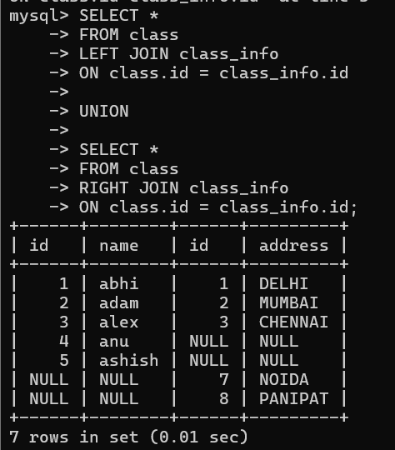

=========================================================
QUESTION 10 - FULL OUTER JOIN
=========================================================

SCENARIO:
Audit team wants unmatched records from both tables.

QUERY:

SELECT *
FROM class
FULL OUTER JOIN class_info
ON class.id=class_info.id
WHERE class.id IS NULL
OR class_info.id IS NULL;

OUTPUT:
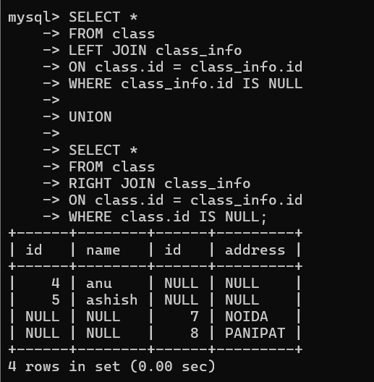

=========================================================
PART 7: UNION
=========================================================
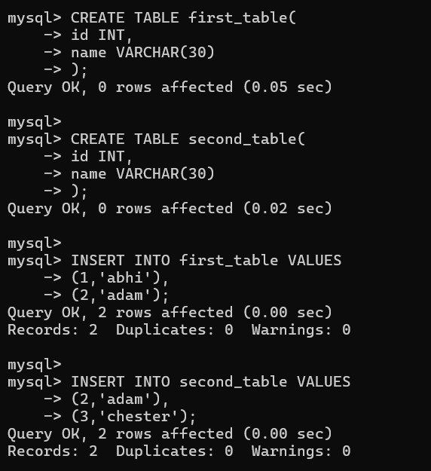

=========================================================
QUESTION 11 - UNION
=========================================================
SCENARIO:
Management wants a combined list without duplicates.

QUERY:
SELECT * FROM first_table
UNION
SELECT * FROM second_table;

OUTPUT:
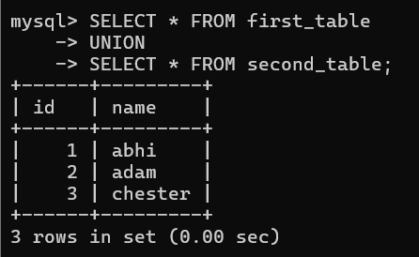

=========================================================
QUESTION 12 - UNION
=========================================================
SCENARIO:
Generate a master student list from two branches.

QUERY:
SELECT name FROM first_table
UNION
SELECT name FROM second_table;

OUTPUT:
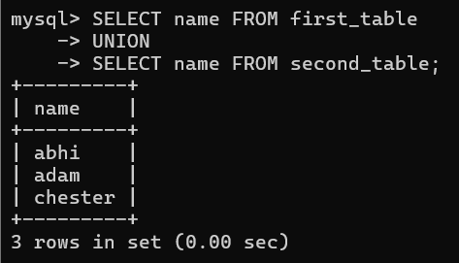

=========================================================
PART 8: UNION ALL
=========================================================

QUESTION 13 - UNION ALL
=========================================================
SCENARIO:
Management wants all records including duplicates.

QUERY:
SELECT * FROM first_table
UNION ALL
SELECT * FROM second_table;

OUTPUT:
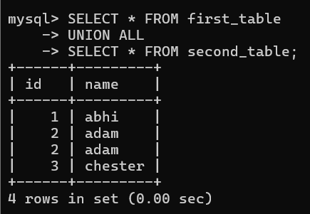

=========================================================
QUESTION 14 - UNION ALL
=========================================================

SCENARIO:
Count total records from both branches.

QUERY:

SELECT COUNT(*)
FROM
(
SELECT * FROM first_table
UNION ALL
SELECT * FROM second_table
) A;

OUTPUT:
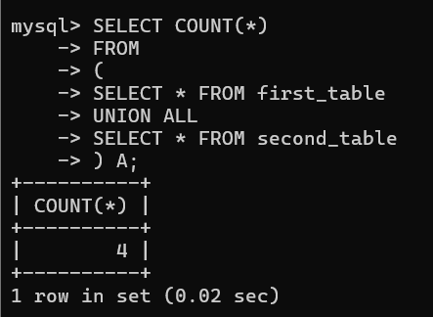

=========================================================
PART 9: INTERSECT
=========================================================
QUESTION 15 - INTERSECT
=========================================================
SCENARIO:
Find students present in both branches.

QUERY:
SELECT * FROM first_table
INTERSECT
SELECT * FROM second_table;

OUTPUT:
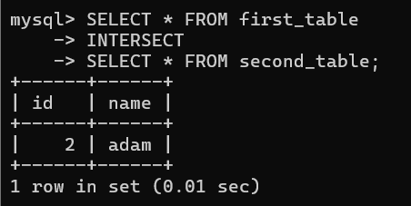

=========================================================
QUESTION 16 - INTERSECT
=========================================================
SCENARIO:
Find common student names.

QUERY:
SELECT name FROM first_table
INTERSECT
SELECT name FROM second_table;

OUTPUT:
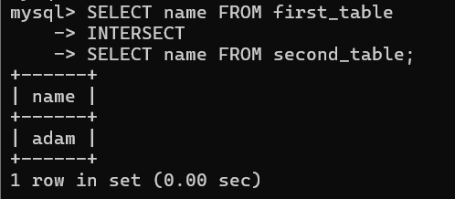

=========================================================
PART 10: MINUS
=========================================================
QUESTION 17 - MINUS
=========================================================
SCENARIO:
Find students present only in the first branch.

QUERY:
SELECT * FROM first_table
MINUS
SELECT * FROM second_table;

OUTPUT:
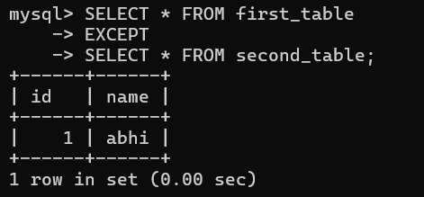

=========================================================
QUESTION 18 - MINUS
=========================================================
SCENARIO:
Find names that exist only in first_table.

QUERY:
SELECT name FROM first_table
MINUS
SELECT name FROM second_table;

OUTPUT:
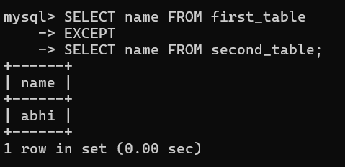

=========================================================
ADVANCED INTERVIEW QUESTIONS
=========================================================
QUESTION 19

SCENARIO:
Find students having matching addresses.

QUERY:
SELECT c.id,c.name,ci.address
FROM class c
INNER JOIN class_info ci
ON c.id=ci.id;

OUTPUT:
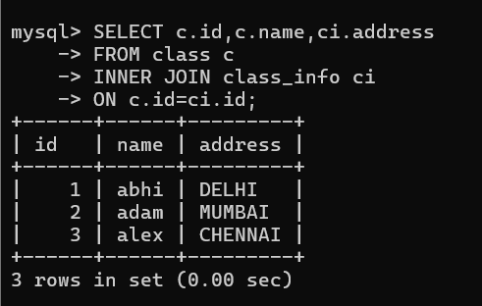

=========================================================
QUESTION 20

SCENARIO:
Generate a report showing all students and address
availability status.

QUERY:
SELECT c.id,
c.name,
CASE
WHEN ci.address IS NULL
THEN 'Address Missing'
ELSE 'Address Available'
END AS Status
FROM class c
LEFT JOIN class_info ci
ON c.id=ci.id;

OUTPUT:
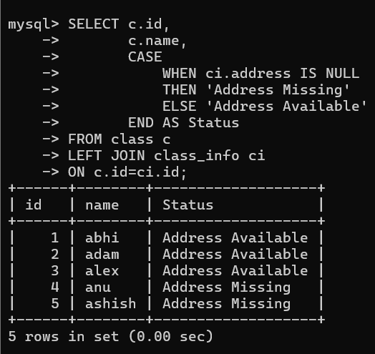

=========================================================
TOPICS COVERED
=========================================================
1. CROSS JOIN
2. INNER JOIN
3. NATURAL JOIN
4. LEFT OUTER JOIN
5. RIGHT OUTER JOIN
6. FULL OUTER JOIN
7. UNION
8. UNION ALL
9. INTERSECT
10. MINUS
11. CASE
12. JOIN + WHERE
13. JOIN + NULL
14. JOIN + FILTERING
=========================================================

